Quiz 1: Introducing spreadsheets

1 Formulae, replication and referencing

- Match the mathematical operators to the correct symbols.
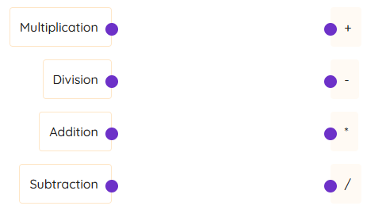
2. Is this statement true or false? A relative cell reference will not change when a formula is replicated.
- True
- False

- Is this statement true or false?
An example of an absolute cell reference is: =$A$2
- True
- False

- Select the correct answer. Look at the spreadsheet below: The formula in C1 is replicated to cells C2 and C3. What will the formula in cell C2 be?
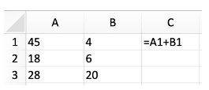
- =A1+B1
- =A2+B1
- =A2+B2
- =A1+B2

Look at the spreadsheet below:The formula in C1 is replicated to cells C2 and C3. What value will be shown in cell C3?
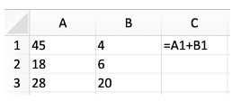
- 26
- 48
- 24
- 49

5. Select the correct answer. Look at the spreadsheet below: The formula in C1 is replicated to cells C2 and C3. What will the formula in cell C2 be?
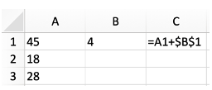
- =A2+$B$2
- =A2+$B$1
- =A1+$B$1
- =A1+$B$2

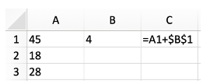
Look at the spreadsheet below: The formula in C1 is replicated to cells C2 and C3. What value will be shown in cell C3?
- 32
- 22
- 28
- 18
2 Functions using SUM, AVERAGE, MAX and MIN

1.Drag and drop the correct words from the list to complete the sentences.
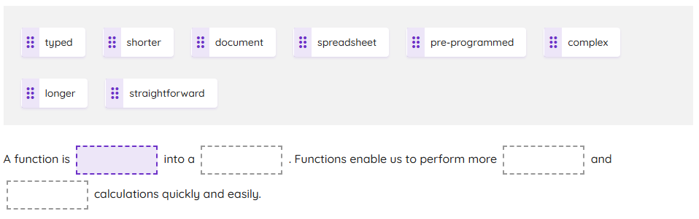

2.Type the correct answers into the gaps.
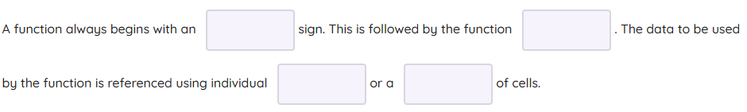

3.
Select the correct function.
Which function is used to find the average of the values in a range of cells?
- =MAX
- =MIN
- =SUM
- =AVERAGE

Which function is used to find the smallest value in a range of cells?
- =MAX
- =MIN
- =SUM
- =AVERAGE

Which function is used to find the total value of a range of cells?
- =MAX
- =MIN
- =SUM
- =AVERAGE

Which function is used to find the largest value in a range of cells?
- =MAX
- =MIN
- =SUM
- =AVERAGE

3 Boolean operators and the IF and COUNT functions
1.Connect the correct Boolean operator to each comparison.
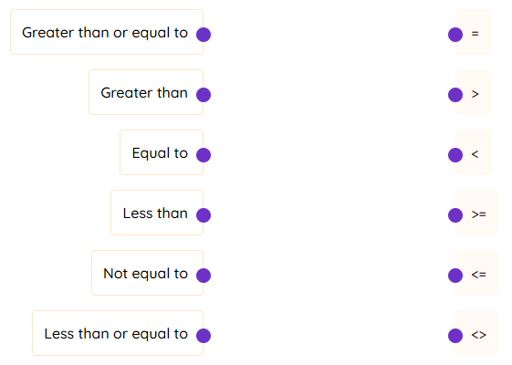

2.Select the correct function. Which function is used to count the number of cells in a selected range that contain text or numbers?
- =COUNT
- =COUNTA
- =COUNTIF

Which function is used to count the number of cells in a selected range that meet a specific criterion?
- =COUNT
- =COUNTA
- =COUNTIF

2.Select the correct function.
Which function is used to count the number of cells in a selected range that contain text or numbers?
- =COUNT
- =COUNTA
- =COUNTIF
Which function is used to count the number of cells in a selected range that meet a specific criterion?
- =COUNT
- =COUNTA
- =COUNTIF

3.Drag and drop the correct word from the list to complete the sentences.

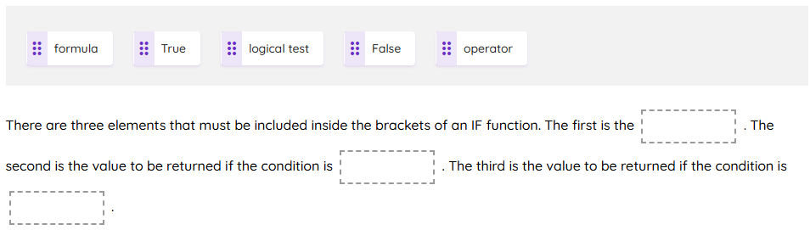
4 Formatting, graphs and charts

1.Drag and drop the correct words from the list to complete the sentences.

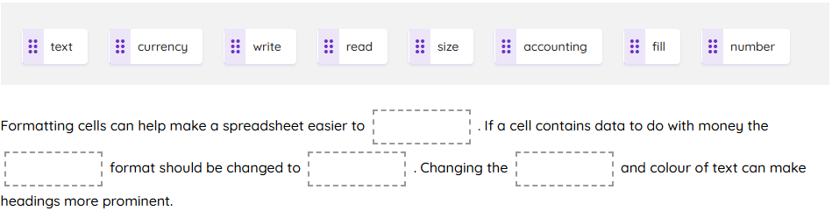

2. Select the correct formatting rule.
Look at the spreadsheet below:
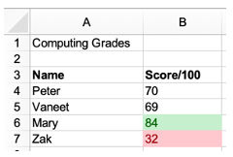
Which of the following conditional formatting rules has been applied to cell B6?
- Cell value >84 Format: Light green fill
- Cell value <84 Format: Light green fill
- Cell value >=84 Format: Light green fill

Look at the spreadsheet below: Which of the following conditional formatting rules has been applied to cell B7?
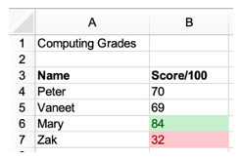
- Cell value >33 Format: Light red fill
- Cell value <33 Format: Light red fill
- Cell value >=33 Format: Light red fill

3.Match each graph or chart to its most appropriate use.
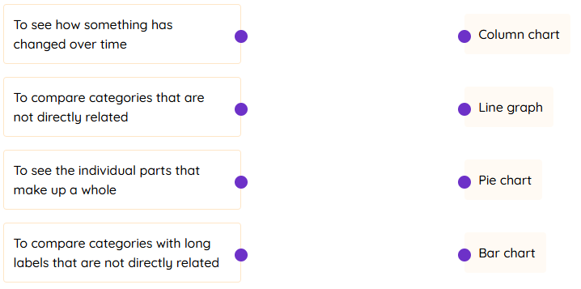

5 Modelling

1.Modelling can be used to help with which one or more of the following?
- Designing a building
- Projecting the spread of a disease
- Writing an essay
- Predicting profit and loss

2.
Modelling is useful for which one or more of the following?
- It always gives the perfect answer.
- It can be easy to set up and perform using spreadsheets.
- It is possible to try out different scenarios.
- It enables us to predict what is likely to happen when something changes.

3.
Select the correct answer.
Goal Seek allows you to see how changing one value will affect another. True or false?
- True
- False

Goal Seek is applied to cells in the following spreadsheet: Which cell needs to be set to a specific value to model a profit of 20p per cupcake?
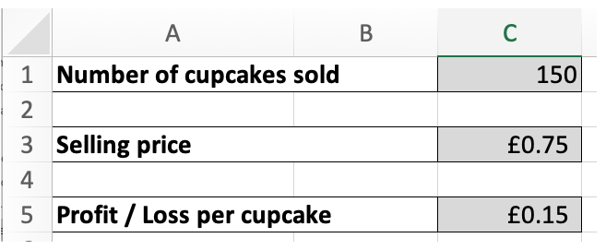

- C1
- C3
- C5

Goal Seek is applied to cells in the following spreadsheet: Which cell's value needs to be changed by Goal Seek to ensure that there is a profit of 20p per cupcake?
- C1
- C3
- C5

What sort of questions does Goal Seek allow you to answer?
- Yes / No questions
- Multiple-choice questions
- What-if questions

